ANSWERS(ASSIGNMENT 8)

1)A user defined function is a custom function built by the user. It is a reusable block of code in a shell script that performs a certain task that it was designed for. It helps organize large codes and avoids repetition.
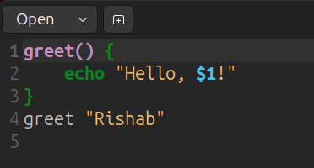
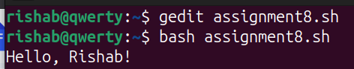

2)
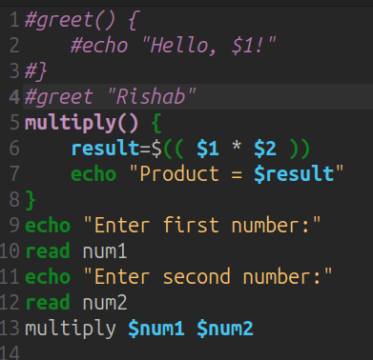

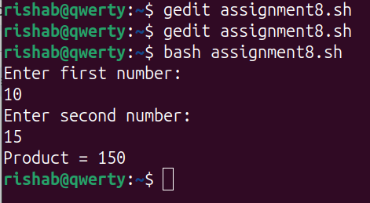

3)Bash scripting supports 1D arrays and associative arrays, but does not have built-in support for true 2D or 3D arrays.

1D array
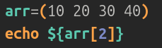
2D array
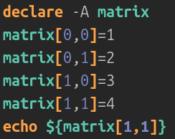

3D array
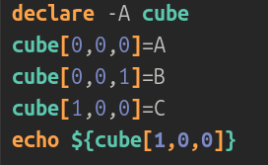
OUTPUT
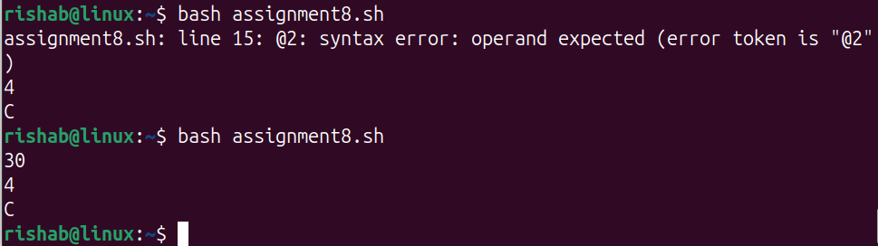

4)
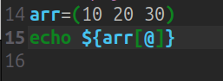
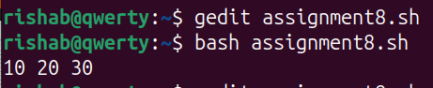

5)’CRON’ in bash is used to schedule tasks. It automatically runs tasks at specified time intervals. It’s useful for automating repetitive system maintenance tasks like backups or updates.
Example; backups, log records, system maintenance

6)First let’s create a file named “backup.sh” using the touch command
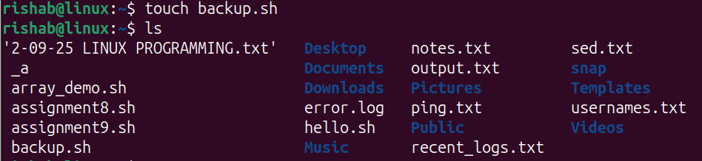
Next, let's check whether crontab is installed or not using “crontab -l” command.
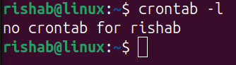
Next, let's install crontab using the “crontab -e” command.
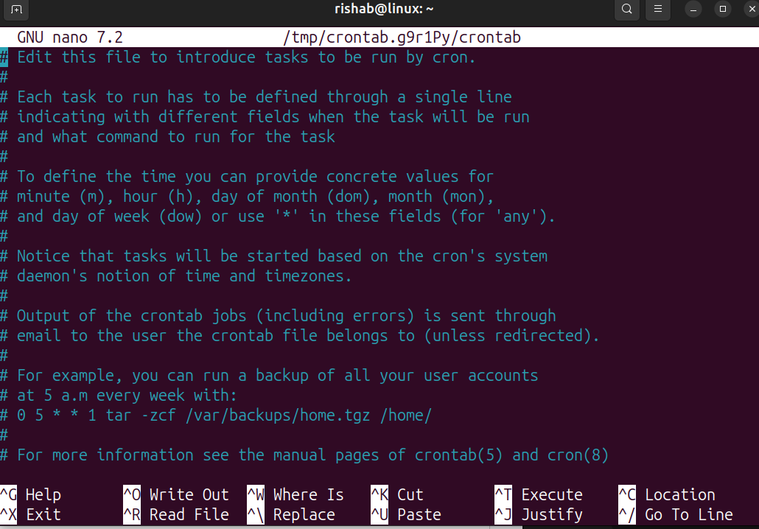

After this let’s write a line that schedules a task of running the file backup.sh every day at midnight.
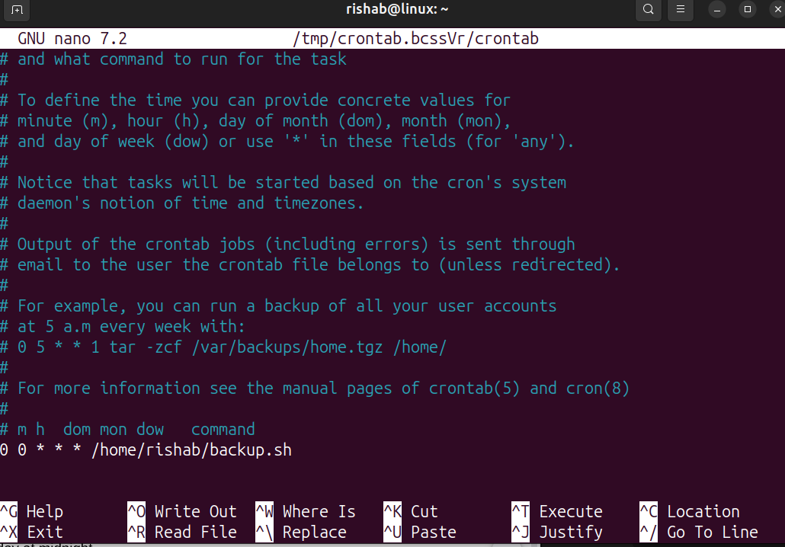

7)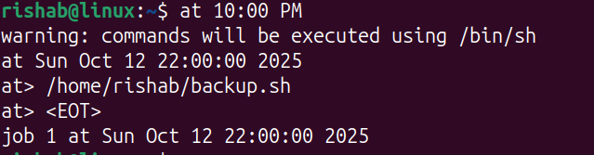

8)
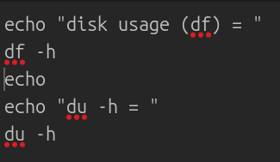

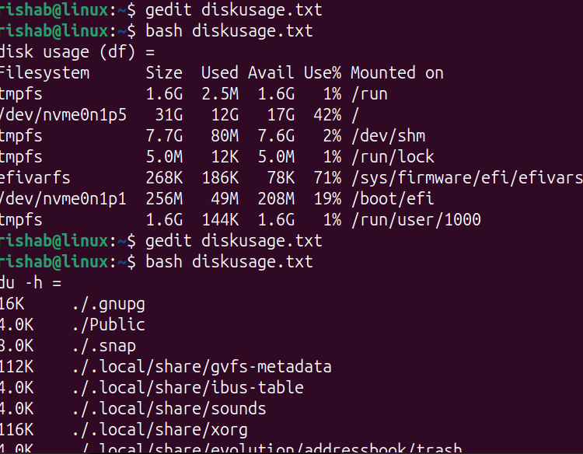

9)We can use the “tee” command.
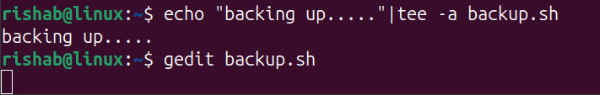
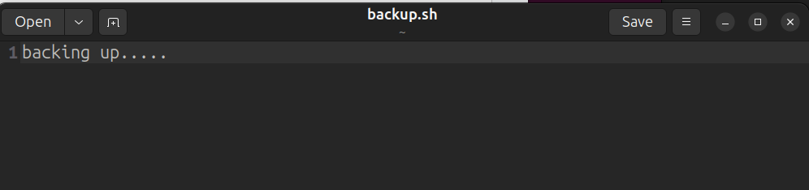

10)Shell scripting automates repetitive system administration tasks such as backups, updates, user management, and log cleanup. We can use CRONJOB to run a simple script to back up the “/home” directory every day. It saves both time and human effort.
